**Report**

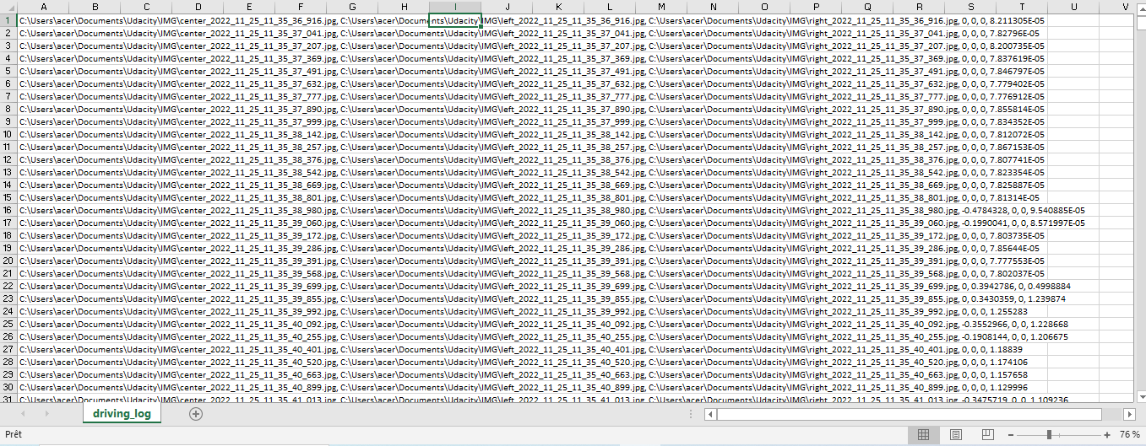This session I did a lot of research because we were blocked because of the NVIDIA card, the wifi didn’t work in this card and so we were blocked to download NANO in it (Nano is a command in SSH that simplifies the coding). So I turned to other software like COLAB that I used to start coding. To start deep learning, I used the simulation software UDACITY, which allows us to drive and train an autonomous car on a track and it acquires pictures. We’re going to have three types of images: images of a camera that will be in the center of the car, images of a camera that will be further to the left of the car, and images of a camera that will be further to the right of the car. It also provides us with a CSV which is an Excel file, on line (see picture below), and in each line it mentions the time of taking the picture, the acceleration of the car, and its degree of inclination.

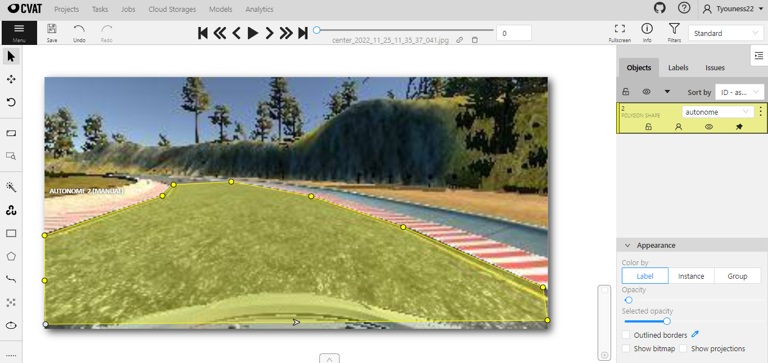Our goal is to create an algorithm that will be able to automatically segment the road from the images taken by the camera in the center of the car. Then I moved on to the part of Data Science using the software, which is to label and segment images. Using the CVAT software, we will segment a hundred images which will take us a lot of time.